How to Stop and Start EC2 instance with Lambda

1. Create EC2 instance

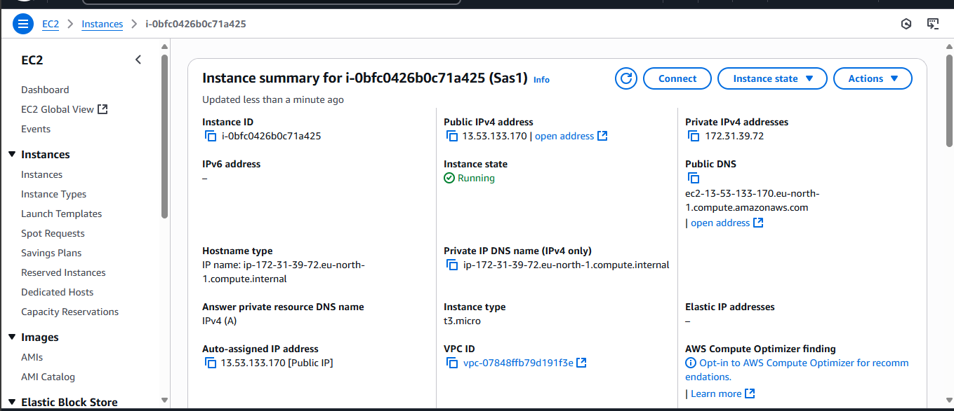

1. Create IAM policy

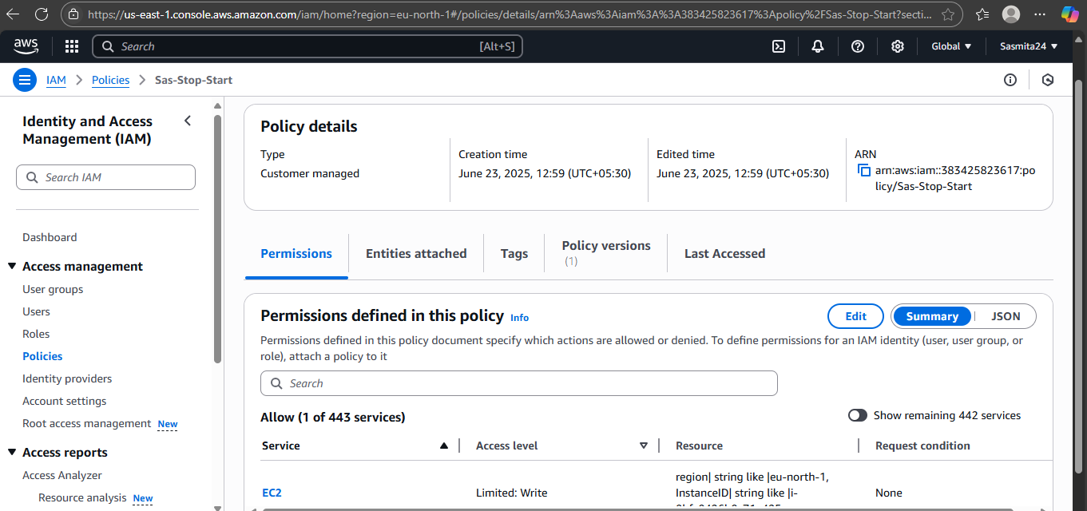

1. Create IAM role, attach policy with role.

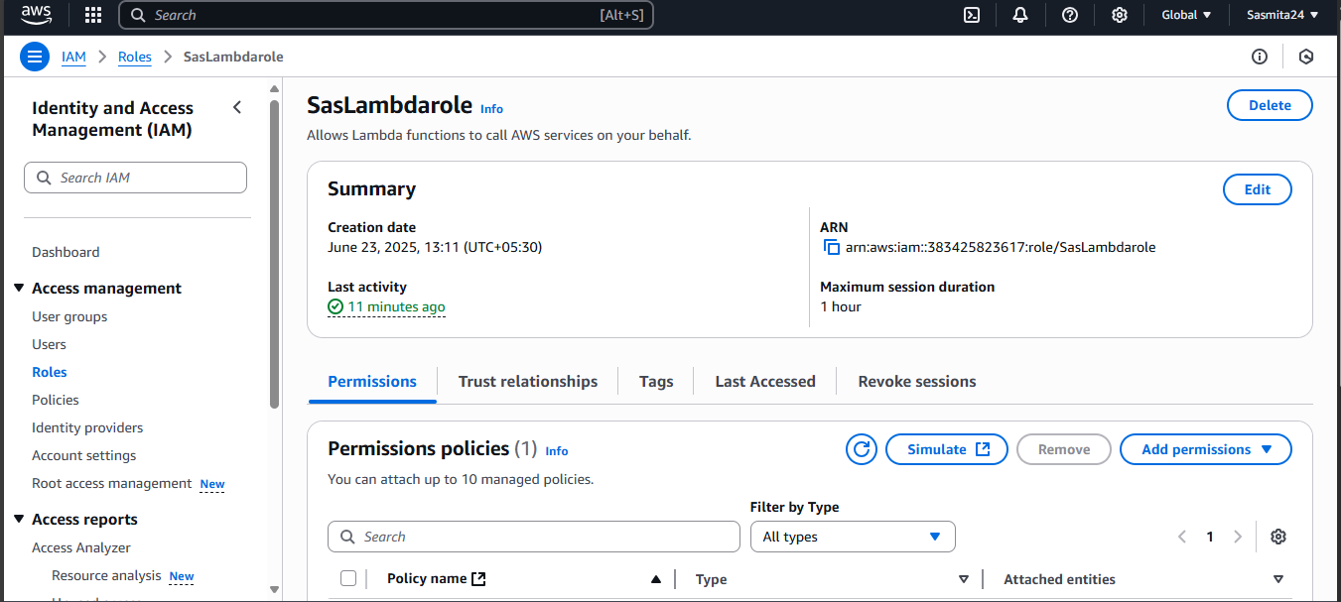

1. Create Lambda function, attach the role with Lambda function.

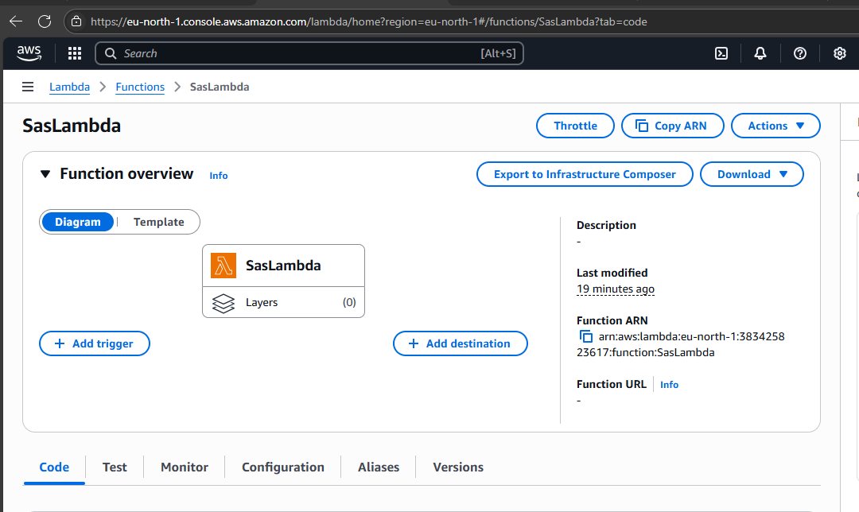

Get the code from developer for start and stop EC2 instance, verify region, instance and version then create even and Deploy / test.

Here’s how to **create an IAM user** with administrator access in AWS and **add them to the Administrator group** step-by-step:

**🛠 Step-by-Step Instructions (via AWS Console)**

**1. Sign in to AWS Management Console**

* URL: https://console.aws.amazon.com/
* Sign in as a user with permission to manage IAM (e.g., root or admin)

**2. Create IAM Group: "Administrator Group"**

If not already created:

1. Go to **IAM > User groups**
2. Click **"Create group"**
3. Name it: AdministratorGroup
4. In **Attach permissions policies**, search for and select:
   * AdministratorAccess policy
5. Click **"Create group"**

**3. Create IAM User**

1. Go to **IAM > Users**
2. Click **"Add users"**
3. Set user name: e.g., john.doe
4. Select **"Provide user access to the AWS Management Console"**
   * Set a custom password or auto-generate one
   * Require password reset on first sign-in (optional)

**4. Add User to Administrator Group**

1. On the "Set permissions" page, choose:
   * **"Add user to group"**
2. Select the checkbox next to **AdministratorGroup**
3. Continue through the steps and click **"Create user"**

**✅ Result**

* A new user is created (e.g., john.doe)
* They have full admin access via the AdministratorAccess policy inherited from the group
* Can log in to AWS Console and use all services

**📌 Best Practices**

* **Enable MFA** for the user
* Track access using **CloudTrail**
* Consider using **AWS SSO** or **Identity Center** for enterprise-level identity management

Let me know if you’d like the same steps using the **AWS CLI** or **Terraform**.

**You said:**

Create a user for an employee of the company who requires administrator access to the company's AWS account, and then add the user to the Administrator Group. how to do this

**ChatGPT said:**

Here’s **how to create a user and assign administrator access** in AWS using the **AWS Console**, **AWS CLI**, and a quick note on **best practices**.

**✅ Option 1: AWS Management Console (Step-by-Step)**

**🔹 Step 1: Sign in to AWS**

Go to: https://console.aws.amazon.com/

**🔹 Step 2: Create IAM Group (if not already created)**

1. Navigate to **IAM** > **User groups**
2. Click **“Create group”**
3. Name the group: AdministratorGroup
4. Attach policy: AdministratorAccess
5. Click **“Create group”**

**🔹 Step 3: Create a New IAM User**

1. Go to **IAM** > **Users**
2. Click **“Add users”**
3. Enter a **username** (e.g., john.doe)
4. Select:
   * ✅ **"Provide user access to the AWS Management Console"**
   * Choose password options (auto-generate or custom)
   * Require password reset on first login (recommended)

**🔹 Step 4: Add User to Administrator Group**

1. Under **“Set Permissions”**, choose:
   * ✅ **Add user to group**
2. Select **AdministratorGroup**
3. Continue and click **"Create user"**

**🔹 Step 5: Share Login Info**

* Download or copy the login URL and credentials
* Send securely to the employee

To **check and observe the CPU Utilization graph for an EC2 instance** in AWS, follow these steps using the **AWS Console** or **CloudWatch**.

**✅ Using AWS Management Console**

**🔹 Step-by-Step:**

1. **Sign in** to the AWS Management Console
2. Go to **EC2** service
3. In the left menu, click on **Instances**
4. Select the instance whose CPU usage you want to view
5. Scroll down to the **Monitoring** tab (in the lower panel)
6. Look for **CPU Utilization** chart
   * You’ll see a graph showing the CPU usage (%) over time

**🧭 Optional: View in CloudWatch (for more detail)**

1. In the EC2 instance details page, under **Monitoring**, click **“View in metrics”**  
   *(or go to the CloudWatch Console)*
2. In **CloudWatch**, navigate to:
   * **Metrics** > **EC2** > **Per-Instance Metrics**
3. Find the metric: **CPUUtilization**
4. Select your instance
5. Click **“Add to graph”** to see live or historical data
   * Adjust time range (1 hour, 1 day, etc.)

**🔧 Advanced: Enable Detailed Monitoring (optional)**

By default, EC2 monitoring is **every 5 minutes**. You can enable **Detailed Monitoring** (every 1 minute):

1. Select your EC2 instance
2. Click **Actions > Monitor and troubleshoot > Manage detailed monitoring**
3. Enable it (charges may apply)

**📌 Tip**

* If CPU utilization is constantly high (e.g. > 80%), consider:
  + Upgrading instance type
  + Adding auto scaling
  + Optimizing your application

